Where do you sail in
Leadership Tool the sea of leadership?

A tool for recognizing leadership styles within organizations

A tool for recognizing leadership styles within organizations

Introduction

This tool is inspired by the Myers-Briggs Type Indicator (MBTI). Unlike MBTI, it does not classify differences in personality traits. The central goal is to provide insight into the different leadership styles that take place in an organizational context. Based on ten questions with four answer options, preferred styles with regard to leadership are revealed. Because of the simple and clear explanation, it is a valuable tool for managers and employees to reflect on their personal view of leadership. These questions should promote critical, creative, introspective and group dynamic thinking.
By analogy with the title, there are many different forms of leadership. Four different styles are distinguished in this tool. Depending on the size and purpose of the organization, organizations are shaped differently, similar to how different boats are made for different purposes. In the sea there are many different routes that one can sail. Raplh Waldo Emerson, one of the most influential thinkers in the history of the United States, said: "It's not about the destination but the journey."
During the journey, during the existence of organizations, various obstacles have to be faced.
To continue to exist as an organization, the ship must defy obstacles. The storms at sea consist
of high competition, economic crises, large financial losses, turnover and various (un)predictable negative impacts. Leadership plays an important role in overcoming these obstacles and determining the course, the direction of the organization. Storms will pass and organizations will learn to thrive.

In addition you learn other leadership styles by this tool. Our goal is not to give a correct or incorrect picture of a certain leadership style, but to give you experience in the view and behaviour of other styles. You will find that each style offers advantages and disadvantages and is better applicable depending on the situation or organization.
1
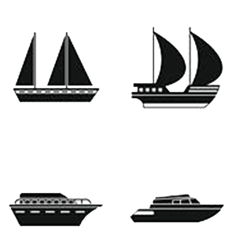
2.
Questionnaire Leadership Tool
Where do you sail in the sea of leadership?

the questionnaire consists of ten questions about leadership styles. there are four answer options for each question. you can only give one answer at a time that is most in line with your own vision. After this you can view the results in the grid

The questionnaire consists of ten questions about leadership styles. There are four answer options for each question. You can only give one answer per question that is most in line with your own vision. View the results in the grid.

1. Leadership can only be successful if:
A. Everyone can take the leadership role and a leader is chosen depending on the situation.
B. Everyone on the team feels good and at ease.
C. Everyone always follows the leader their instructions.
D. Leadership is present in every layer of the organization, in every team.
2. What does leadership mean to you?
A. Leadership is a dynamic process whereby people are challenged to come up with
innovative ideas. Each person has different expertise and a leader is appointed
based on his or her expertise.
B. Leadership is a process in which everyone who participates in the process is treated with equal respect.
C. Leadership is a process that promotes independence and responsibility.
Experimenting is allowed.
D. Leadership is a defined process in which team members under the authority of a leader perform their assigned tasks.
2

3. What do you think a leader should have?
A. Exclusive and unique characteristics.
B. The capacity to both take a leadership position and to be able to work together in a team.
C. The capacity to follow the opinion of the majority while respecting the minorities.
D. The capacity to let go of control and management, but giving direction so that employees know what is expected of them.
4. Should a leader rather be:
A. Dominant.
B. Being a colleague.
C. Being collaborative.
D. Being motivating.

5. My leadership is characterized by the following words:
A. Trust, dialogue, attention and talents.
B. Strong hierarchy, command and control, little dialogue.
C. Avoiding influence and direction, motivating, activating members, mediating.
D. Coaching, facilitator, encouraging bottom-up initiatives.

6. If you were a head of a state, who would you be?
A. Jozef Stalin.
B. Barack Obama.
C. Karl Marx.
D. Winston Churchill.

3

3

7. If you wanted to add a quality to yourself, what would it be:
A. More perseverance, ability to improvise and flexibility.
B. Have more authority over my employees.
C. More expertise in various areas.
D. Better relationship with employees and maintaining
a good balance between the well-being of the employees and the business.

8. Do you choose to work:
A. Process-based.
B. Top down.
C. Bottom-up.
D. In team.

9. The following proverb best describes my view of leadership:
A. Controlling the strings.
B. Many hands make light work.
C. Everyone may use their talents.
D. When the moon is full, it shines everywhere (If you are happy, everyone can be happy).
10. How do you explain how your team works to a new employee?
A. In our team it is important that everyone feels good.
B. In our team everyone has their own expertise and the team attemps
to use everyone’s strenghts, depending on the situation.
C. In our team everything must be approved by the leader.
D. Everyone can play the role of leader in our team.

4
RESULT
Below you indicate for each question which answer you have given.
Each answer is linked to a color. After this you look at the color that appears most frequently in your answers. Below you can see which leadership style matches with your color. It certainly does not mean that this is your only style,
it is simply the most typical for you. Your leadership is always a combination of different styles. Each style has its advantages and disadvantages and you can get inspiration from other leadership styles.
Question 1 | A = orange | B = green | C = red | D = blue
Question 2 | A = orange | B = green | C = blue | D = red
Question 3 | A = red | B = orange | C = green | D = blue
Question 4 | A = red | B = blue | C = orange | D = green
Question 5 | A = orange | B = red | C = green | D = blue
Question 6 | A = red | B = green | C = blue | D= orange
Question 7 | A = blue | B = red | C = orange | D = green
Question 8 | A = green | B = red | C = orange | D = blue
Question 9 | A = red | B = blue | C = orange | D = green
Question 10 | A = green | B = orange | C = red | D = blue
_{T O T A L} | ……………………..green. | ………………...orange. | ………………………red. | ……………….blue.

RED = authoritarian
5
Characteristic of this style:
- Unilaterally imposes his/her will on his/her employees
- Is not very open to conversations, feedback and discussion
- Is dominant and bossy
- Strong control, monitors the execution of the work
- Makes decisions him or herself and does not leave them to others
- Gives minimal information to the group
- Gives little autonomy to employees
- Does not involve people in the decision-making process
- Determines the purpose, the path to it and its implementation
Possible consequences are:
- Employees are extrinsically motivated instead of intrinsically
because they work for the leader
- Passivity within the team
- Employees often nod yes while they actually do no not agree
- Employees not dare to give their own opinions
- Little sense of responsibility among employees
- Large staff turnover

Link with the field:
The car factory of Henry Ford from the 20th century was an organization where there was strict work specialization and a strong control on the execution of the work. The workers had to follow the instructions of the management precisely. There was a clear separation of thinking and doing.

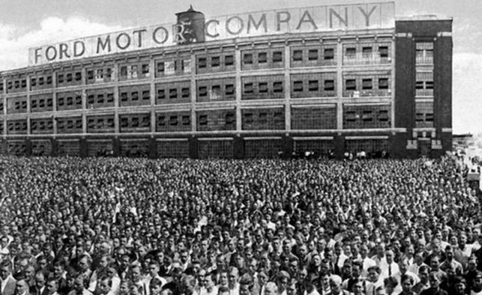
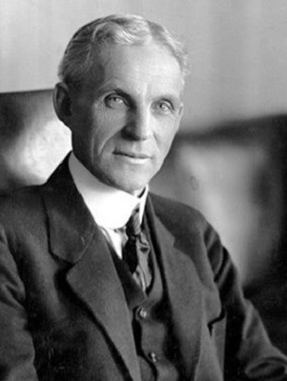
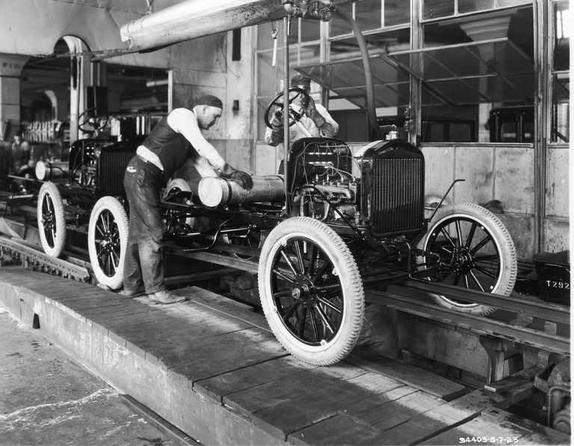
6
BLUE = shared
Characteristic of this style:
- Belongs to a VUCA world
- Hereby people from all levels of the company are trained
to be able to work more independently and responsibly
- Leadership at every level of the organization, in every team
- Involves employees directly in certain facets of the management process
- Has an integrated and strategic view of leadership
- It is obvious to divide tasks between the team
- Based on relational dialogue
- Allows room for other people to take a leadership role
- Work towards a collective goal
- Try to create a win-win situation
- Try to confront his or her employees with new challenges
- Employees are allowed to taste the responsibilities and challenges
which a leader faces on a daily basis
Possible consequences are:
- Provides more flexibility and autonomy for employees
- Both leaders and employees will be able to adapt more quickly
to changing circumstances
- Employees are directly involved in certain facets of
the management process, depending on the situation
- Employees are more committed
- Leaders are given the opportunity to share their workload
- The total knowledge and expertise in the workplace is increased by joining forces
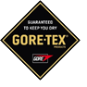
- Retention is promoted because employees are given the opportunity
to prove themselves and as a result remain motivated for a longer time.
Link with the field:
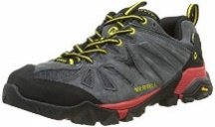
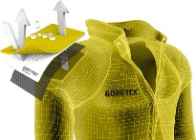
Gore tex regards their employees as the driving force of the business.
They work together from a network communication structure and innovate freely.
7
ORANGE = spread
Characteristic of this style
- Coaching and facilitating role
- An interaction between leaders, followers and the context
- Leadership depends on the situation and the required expertise:
you give colleagues with the most relevant expertise the leading role
in specific situations
- A joint working relationship that promotes collaboration
- Leadership is not a characteristic of individuals, but takes place
when people participate in a process of joint thinking and joint action
- Leader-plus: everyone can lead and does this based
on his or her own expertise, qualities and affinities
- There is an informal division of tasks
Possible consequences are:
- Employees meet each other more and think
constructively together about solutions
- Ensures that employees continuously develop professionally
and pay a lot of attention to improvement and innovation
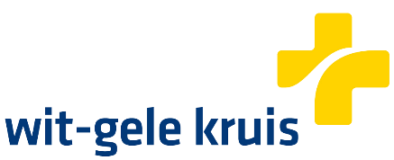
- Employees are intrinsically motivated to bring out the best together without too much help from above

Link with the field:
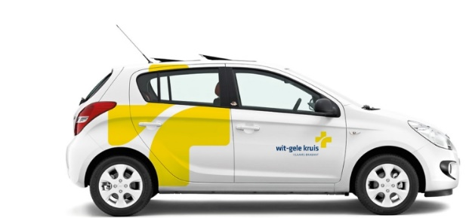
Wit-Gele Kruis is one of the pioneers of Flanders in spread leadership. They have introduced
new work models to give employees more autonomy. Where they used to have three to four layers in the hierarchy, there is now only one. Self-managing teams work at all levels without a boss.
For example, there is no longer a head nurse in the team of nurses. They do everything themselves, and when they fail, they ask for help by a coach. They believe that this type of leadership is positive for their organization because fewer hierarchical layers ensure more agility and adequate solutions.
8
GREEN = democratic leadership
Characteristic of this style:
- Motivating employees
- The leader's influence on the processes is minimal
- Make decisions together
- It is important to keep employees happy
- Consensus-decision making
- Team gets a lot of responsibility
- Employees are encouraged to enter into mutual discussions
- Pay attention to all dynamic processes within the team
- Own interests are set aside for common interests
- Being different from team members is accepted

Possible consequences are:
- Employees feel stimulated in their creativity
- They feel responsible for the results of the team
- They feel involved and solidarity with the organization
- Team members feel motivated
- Tasks or problems are a common responsibility
- We-feeling is strong
Link with the field:
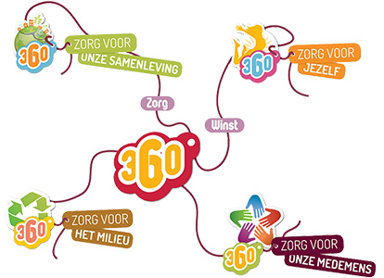
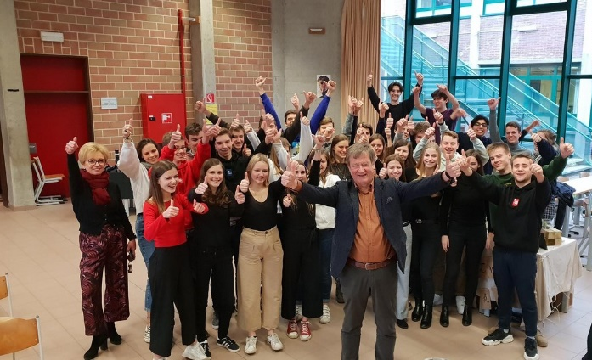
Torfs is a family business that adopts the democratic leadership style. Their slogan is: 360° care
leads to 360° profit. It is very important for them to take care of their employees. For example,
they organize employee days, the employees recieve a holiday on their birthday and they regularly recieve presents.
9
Care for society,
Care for yourself,
Care for the environment,
Care for our fellow man
SHARED LEADERSHIP | AUTHORITARIAN LEADERSHIP
SPREAD LEADERSHIP | DEMOCRATIC LEADERSHIP
Help my employees do not co-operate! What now?
Where are you on the leadership spectrum?
There is not one correct leadership style.
Your leadership is always a combination of different styles.

Answer sheet
Answer 1
Answer 2
Answer 3
Answer 4
Answer 5
Answer 6
Answer 7
Answer 8
Answer 9
Answer 10

10
Four leadership styles

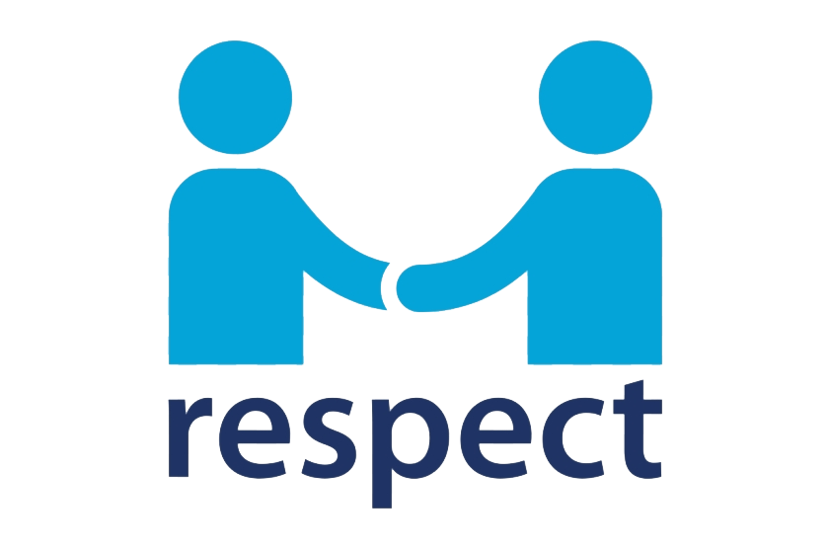
l | Authoritarian leadership
ll | Democratic leadership
lll | Shared leadership
IV | Spread leadership

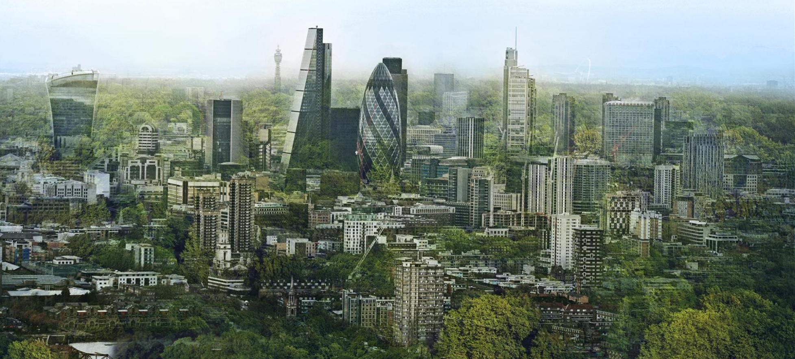

11

